MitM Sniffing & SIEM Monitoring & Snort (NIDS)

Data Sniffing Lab Report

1. Objective
The primary objective of this lab is to demonstrate how unencrypted network traffic (HTTP) can be intercepted using a Man-in-the-Middle (MitM) attack vector via ARP Spoofing, and to highlight the critical risk of transmitting sensitive data in plaintext.

2. Network Environment Setup
The lab environment consists of an isolated Host-Only network topology with the following components:
- Attacker Machine: Kali Linux VM (192.168.56.105)
- Target Machine (Host): Windows Laptop (192.168.56.1)
- Vulnerable Web Server: Metasploitable 2 VM (192.168.56.106)

3. Step-by-Step Execution Procedure

Step 1: Network Reconnaissance
The network interface eth1 was initialized inside Bettercap on the attacker machine using the command:

A network probe was executed using net.probe on to discover active hosts. The net.show command successfully mapped the active IP addresses and MAC mappings of the environment.

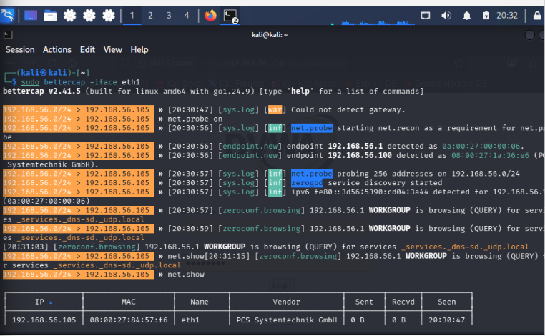

Step 2: Launching the ARP Spoofing Attack
Due to the absence of an external virtual gateway on the Host-Only network adapter, a targeted internal ARP spoof was initiated. The target was specified to direct traffic securely through the attacker's instance:
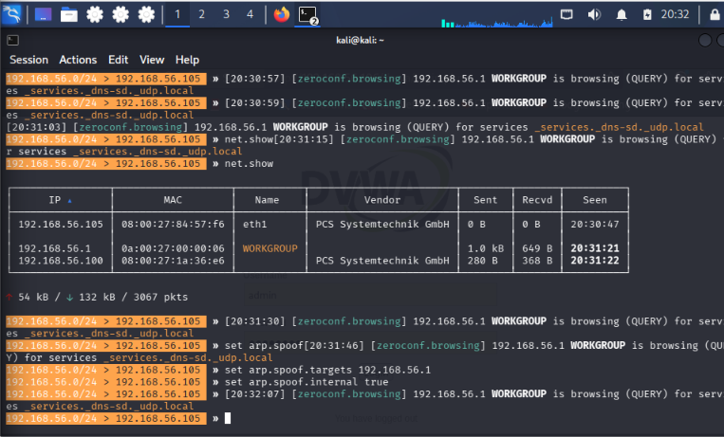
This forces the target host machine to update its local cache, positioning the Kali Linux machine directly in the middle of the communication stream.

Step 3: Traffic Sniffing Activation
To observe the plaintext payloads in real-time, the packet sniffer module was enabled:
Plaintext
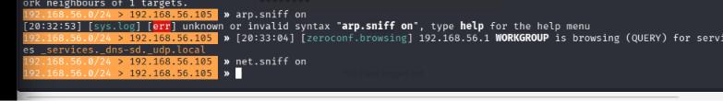 on

4. Analysis and Proof of Concept (Credential Capture)
The target initiated an unencrypted HTTP session by navigating to the Damn Vulnerable Web Application (DVWA) login interface hosted at http://192.168.56.106/dvwa/login.php.
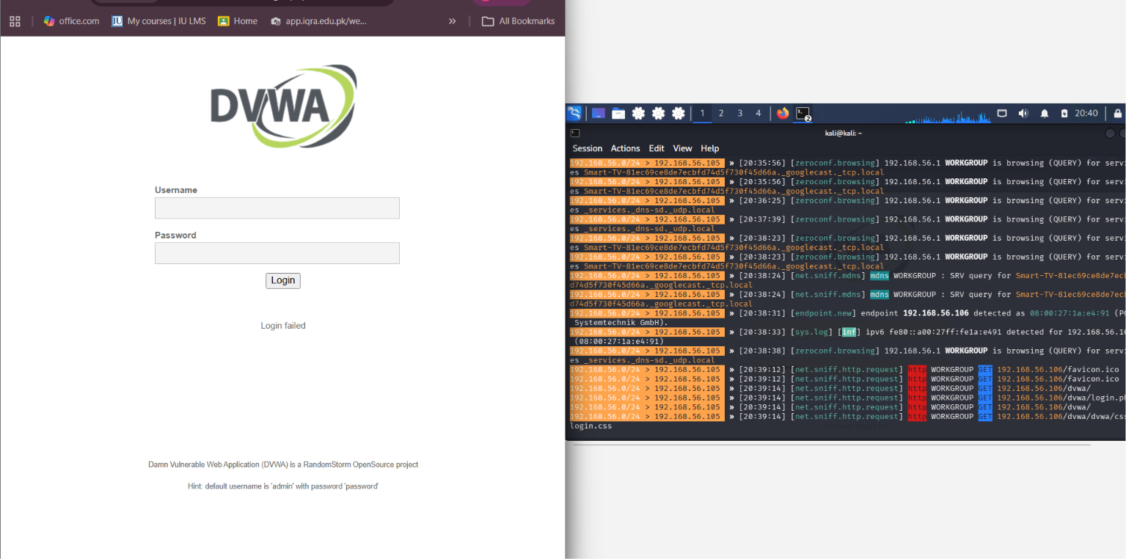
Once the victim submitted their credentials on the application interface, the packet sniffing module captured the outbound POST request parameters traversing the local interface.

Intercepted Evidence Payload:
HTTP
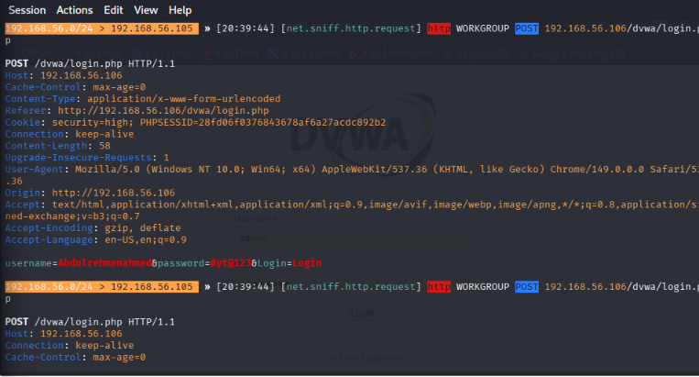
Observations: As demonstrated in the console output, Bettercap successfully isolated the exact parameter strings for both the username and password fields in clear text without requiring decryption mechanisms.

5. Defensive Mitigations
- Enforce HTTPS (TLS/SSL): All web applications must use encrypted channels to prevent plaintext data from being readable during transport layer sniffing.
- Static ARP Configuration / DAI: Implementing Dynamic ARP Inspection (DAI) on network switches prevents unauthorized devices from broadcasting rogue ARP replies.
- Network Monitoring (IDS): Utilizing intrusion detection systems like Snort configured on the interface can immediately flag repetitive or inconsistent ARP mapping patterns.

6. Snort Alert Generation:
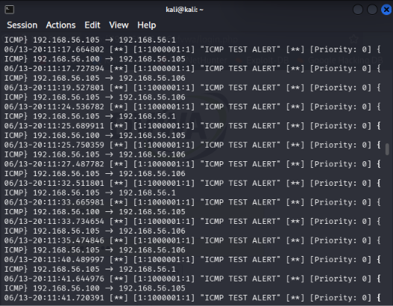
Bhai, report ko bilkul short aur to-the-point kar diya hai. Ise copy-paste karke directly apne Word document ya Google Docs mein daal lein, yeh minimum pages gheregi:

Wazuh Monitoring:

1. Objective
To execute an ARP Spoofing Man-in-the-Middle (MitM) attack to capture cleartext credentials and verify centralized event logs using the Wazuh SIEM Dashboard.

2. Setup Details
- Attacker: Kali Linux VM (192.168.56.105)
- Victim: Windows Laptop Host (192.168.56.1)
- Target Server: Metasploitable 2 (192.168.56.106)
- SIEM Platform: Wazuh Appliance (v4.14.5)

